Week 1 | Week 2 & 3 | Week 2 & 3 | Week 4 & 5 | Week 4&5 | Week 6 & 7 | Week 6 & 7
Theme: Rain Before Rainbows | Theme: British Destinations - Wales | Theme: British Destinations - Scotland | Theme: Black History Month – Space Scientists | Theme: Black History Month - Windrush | Theme: Black History Month – Bus Boycotts | Theme: Black History Month – Voices Series
Extracts and TV Clip:  - Rain Before Rainbows (full Picture Book).  - Silky and the Rainbow Feather.  - The Rainbow Orchid. | Extracts:  - The Wales Way tourism video.  - Framed.  - The Song of the Mischievous Dog (poem). | Extracts:  - Visit Scotland tourism video.  - The Ballad of Nessie.  - The Weather Weaver. | Extracts:  - Mae Among the Stars.  - Work it Girl: Mae Jemison.  - Inspiring Scientists: Maddie Aderin-Pocock. | Extracts:  - Coming to England (full Picture Book).  - Coming to England.  - What is the Windrush Generation Newsround article. | Extracts:  - Little People, Big Dreams: Rosa Parks.  - Rosa Parks BBC Bitesize article.  - The Story of the Bristol Bus Boycotts video. | Extracts:  - Now or Never.  - Diver’s Daughter.  - A Victorian Story.
24 pieces of Tier 2 and Tier 3 vocabulary.  18 retrieval questions. | 22 pieces of Tier 2 and Tier 3 vocabulary.  18 retrieval questions. | 16 pieces of Tier 2 and Tier 3 vocabulary plus challenge day.  12 retrieval questions plus research challenge. | 19 pieces of Tier 2 and Tier 3 vocabulary.  18 retrieval questions. | 19 pieces of Tier 2 and Tier 3 vocabulary.  18 retrieval questions. | 23 pieces of Tier 2 and Tier 3 vocabulary.  18 retrieval questions. | 18 pieces of Tier 2 and Tier 3 vocabulary.  18 retrieval questions.
 | 7 EXTENSION questions to stretch learners. | 6 EXTENSION questions to stretch learners. | 4 EXTENSION questions to stretch learners. | 8 EXTENSION questions to stretch learners. | 6 EXTENSION questions to stretch learners. | 9 EXTENSION questions to stretch learners.
Content Domains covered: 2a, 2b, 2c, 2d, 2e, 2f, 2g, 2h | Content Domains covered: 2a, 2b, 2c, 2d, 2e, 2f, 2g, 2h | Content Domains covered: 2a, 2b, 2c, 2d, 2e, 2f, 2g, 2h | Content Domains covered: 2a, 2b, 2c, 2d, 2e, 2f, 2g, 2h | Content Domains covered: 2a, 2b, 2c, 2d, 2e, 2f, 2g, 2h | Content Domains covered: 2a, 2b, 2c, 2d, 2e, 2f, 2g, 2h | Content Domains covered: 2a, 2b, 2c, 2d, 2e, 2f, 2g, 2h
Website Link | Website Link | Website Link | Website Link | Website Link | Website Link | Website Link
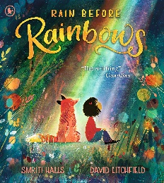 | 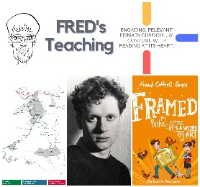 | 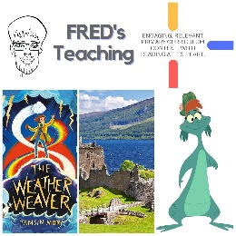 |  |  | 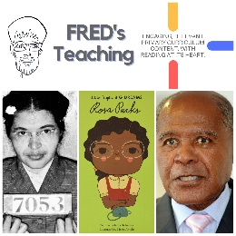 | 

